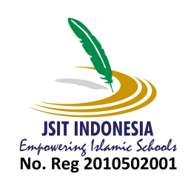
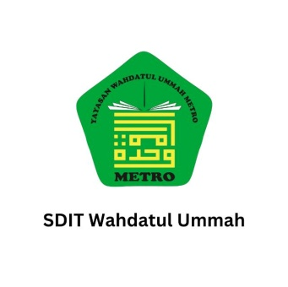
YAYASAN WAHDATUL UMMAH METRO
SDIT WAHDATUL UMMAH
Mengemban Amanah Mewujudkan Generasi Rabbani
Alamat : Jl. Ikan Koi No.5 21A Kelurahan Yosorejo Kecamatan Metro Timur Kota Metro 34112

DATA PESERTA DIDIK BARU WAWANCARA PPDB GELOMBANG 2
HARI/TANGGAL |  | : KAMIS/ 12 DESEMBER 2024
JAM |  | : 07.15 - 09.30 WIB
NO | NAMA SISWA | JK | ASAL TK
1 | Hamizan Albirru Muda | L | Tk A Wu
2 | Atharrazka Danish Pradipa | L | Tk Muslimat Pekalongan
3 | Arrazi Abimanyu Ishak | L | Kober Sakura 29 Metro
4 | Indah Aisyah Putri | P | Tk It Wahdatul Ummah
5 | Namira Azzahra | P | Tk Al Quran Wahdatul Ummah
6 | Muhammad Sandiaga Hafidz | L | Tk Wu
7 | Zidane Adnan Frediyan | L | Tk Wahdatul Umah
8 | Muhammad Atharrazka Susilo | L | Tk Wu
9 | Agrata Dhafin Runako | L | Wahdatul Ummah
10 | Arjuna Giorgino Arifin | L | TK Wahdatul Ummah
11 | Devano Rajendra Santoso | L | Tk Al-Qur'an Wahdatul Ummah
12 | Muhammad Abrisam Nawawi Hidayatullah | L | Tk Al-Qur'an Wahdatul Ummah
13 | Maulida Lulu’ Fathiyaturahma | P | Tk It Wahdatul Ummah
14 | Muhammad Zukhruf Fiansyah | L | Tk Al-Alqur'an Wahdatul Ummah
15 | Naradhipta Abitriatama | L | Tkit Wahdatul Ummah
16 | Maylafaisha Kennocha Prista | P | Tk Wu
17 | Arabella Bagiandsyah Lesmana Yusuf | P | Ra. Al Azhar
18 | Shanum Qaleysa Malik | P | Tkit Wahdatul Ummah
19 | Azura Ghania Putri | P | Tk Aisyiyah Pekalongan
20 | Ayesha Nuha Mamesah | P | Tk Al-Qur'an Wu
21 | Elbarra Albyrafa Rosidi | L | TK Al Qur'an Wahdatul Ummah
22 | Mikhayla Azkadina Mahreen | P | Tk Wu
23 | Fathan Daniel Efendi | L | Tk Al-Qur'an Wahdatul Ummah
24 | Fuad Bassam Abdullah | L | Tk It Al Furqon Kotagajah
25 | Alisha Atthaya Medina | P | Tk Alquran Wahdatul Ummah
26 | Abidzar Vidi Assalam | L | Tk Pertiwi Metro
27 | Yumna Zahida Al Hanan | P | Tk Wahdatul Ummah
28 | Er Rika Ar Rayah Artiyuda | P | Tk Mata Hati Bandar Lampung
29 | Anindita Yumna Al Insani | P | Tkit Wu
30 | Myeasa Ghasia Adeeva | P | Tk Wahdatul Ummah Ii
31 | Ali Mubarak Hadisaputra | L | Tk Wu
32 | Abiyyu Fajr Al Khalifi | L | Tk It Wahdatul Ummah Metro
33 | Naura Khaliqa Dzahin | P | Tk Pertiwi Metro
34 | Myiesha Cordellia Adeeva | P | Tk Wu Kota Metro
35 | Ceisya Aisyah Fajikri | P | Darrol Datha
 |  |  | Kepala SDIT Wahdatul Ummah
 |  |  | Fitriya Ningsih, S.Pd.I
 |  |  | NIP.-

